STRRAP II- AN INTEGRATED SYSTEM FOR RISK ANALYSIS AND EMERGENCY PLANNING

Sandra M. Godoy¹, Alejandro S. M. Santa Cruz¹, Nicolás J. Scenna^{1,*}

¹GIAIQ - Grupo de Investigación en Informática Aplicada a la Ingeniería Química -Universidad Tecnológica Nacional - Facultad Regional Rosario - Argentina
² INGAR - Instituto de Desarrollo y Diseño (Fundación ARCIEN – CONICET) - Santa Fe – Argentina
*To whom all correspondence should be addressed
Tel.:+54-342-4534451/5568; fax: +54-342-4553439
E-mail address: nscenna@ceride.gov.ar

Key words: Hazardous material diffusion, Deterministic models, Stochastic parameters

Abstract
The purpose of this work is to extend the applications of STRRAP system. It is used for risk analysis and local emergency planning calculations.
STRRAP is orientated to the study of less frequent events but capable of giving rise to catastrophic situations either from fixed installations or hazardous-substances transportation accidents which represent a high environmental risk. Up to now, the system has been optimized as regards computing time and methodology, but it is only able to model toxic gas releases in the atmosphere. STRRAP considers the stochastic behavior of input parameters of the diffusion model, which are specific of the place under study.
The aim is to modify the methodology and the system architecture to introduce particulate matter, bioaerosols and water diffusion models. Besides, the processing times of applications and user graphical interfaces will be improved in such a way that the new STRRAP version gets a complete and efficient tool for simulating hazardous material diffusion phenomena in different physical support and means of transport.

INTRODUCTION
Nowadays, there are many areas in which the use of suitable techniques to achieve safe management or operations without exposing people’s health or lives to danger is essential. So, it is very important to determine the risk levels, if critical situations derived from technological or transportation accidents that imply releases and/or spills of toxic substances and/or pathogenic microorganisms occur.
Many tools have been developed for calculating pollutant concentrations emitted to the atmosphere from fixed sources (processing plants, nuclear stations, thermoelectric power stations, incineration ovens, waste treatement plants, etc.) or mobile sources (hazardous materials transportation accidents either on road or railway). The isolation and protection distances for different chemical and biological substances are also tabulated [1]. However, in [1] they have been obtained according to geographical and meteorological circumstances quite different from the local ones. Besides, meteorological parameters are considered as the worst case. This situation was solved through a procedure [2]- [4] which considers the local meteorological data as input used for the calculation.
The tools used for environmental risk studies considering the stochastic variability of meteorological parameters, have found high calculation time as a limitation [4], [5]. Nevertheless, the algorithms presented in [4], [6] and [7], that allow reducing that time considerably have been developed.
Being time restrictions solved (specifically problems in hazardous substances transportation) the objective of this work is to include other diffusion models for air (as particulate matter and bioaerosols) and for water, considering the stochastic parameter variability, so as to increase the new software (STRRAP II) version versatility.

POLLUTANT DISPERSION MODELS

Simulation models are valuable methodology tools for determining pollutant dispersion in different physical support. For instance, there is a wide variety of air and water pollutant dispersion models. Some of them have been selected for the STRRAP II software.
A Air dispersion models
There are numerous atmospheric pollutant dispersion models that can be used if the necessary data are available.

1. Gaussian plume model for light or neutral gases.
$\overline{C}=\frac{Q}{2π {uσ}_{x}σ_{y}σ_{z}}\text{exp}\left[−\left(\frac{x^{2}}{2σ_{x}^{2}}+\frac{y^{2}}{2σ_{y}^{2}}+\frac{{\left(z−h\right)}^{2}}{2σ_{z}^{2}}\right)\right]$ (1)
(1) is the basic equation of the Gaussian plume for a high continuous punctual release with a three-dimension dispersion without reflection and thermal inversion.

C = Average concentration at point x, y, z (µg/m3)
Q = Emission rate (g/s)
h = The pollutants sources effective height (m).
σ_{x}, σ_{y}, σ_{z} = Dispersion coefficients (m).
u = Wind speed (m/s).
Some modifications can be carried out in (1) to consider the different environmental conditions, instantaneous punctual releases, ground level and thermal inversion.

2. U. S. Environmental Protection Agency’s (EPA) DEGADIS model for heavy gases.
It is used to determine the levels of toxic gas concentrations due to instantaneous accidental, continuous or transient releases of an only source at ground level. This model solves a system of differential equations based on meteorological parameters, superficial roughness, physic-chemical substance properties and accident scenarios characteristics (flowrates releases, temperature, etc.).

- Particulate matter dispersion model.
Gaussian dispersion models can be applied if the particles are 20μm or less in diameter. Larger particles have a significant gravitational settling velocity rate so, some corrections have to be made on the model to consider the gravity effect as well as the absence of reflection at ground level as it happens with gases.
$C=\frac{Q_{p}}{2π {uσ}_{y}σ_{z}}\text{exp}\left[−\left(\frac{y^{2}}{2σ_{y}^{2}}+\frac{{\left(z−(h−\frac{W_{p}x}{u}\right)}^{2}}{2σ_{z}^{2}}\right)\right]$ (2)
W_{p}: limited gravitational settling velocity of particles.
The other symbols have the same meaning as in (1).

- Bioaerosols dispersion models.
The model to estimate the viability of microorganisms emitted from a fixed source as a function of distance is given by:

$C_{x}=\frac{Q\text{exp}\left(\frac{f}{u}x\right)}{ 2{uσ}_{y}σ_{z}}\text{exp}\left[−\left(\frac{{\left(h\right)}^{2}}{2σ_{z}^{2}}\right)\right]$ (3)
It takes into account the microbial death rate, f ([8]-[10]).

The system version I includes models 1 and 2. Models 3 and 4 with all their variants and their adaptation will be added in STRRAP II.

B Water dispersion model
Transport modeling on surface water, turns to be a valuable method to set possible distances of affectation. In this system only will be included deterministic hydrological models for pollutant transportation. The stochastic component is given by the variability of different scenarios and by model input series (flowrates, rains, etc.)
There are several water quality models which consider the transportation, dispersion and chemical reactions of the pollutant [11]-[13].
One of the unidirectional model for a conservative substance to be included is:

$C(x,t)=\frac{M}{ Ω\sqrt{4{πD}_{L}t}}\text{exp}\left[−\left(\frac{{\left(x−\text{Ut}\right)}^{2}}{4D_{L}t}\right)\right]$ (4)
where
C = Pollutant concentración at point x, at tieme t (µg/m3)
M = Pollutant discharge (g/s)
t = time (s).
D_{L} = Dispersion coefficient (m)
U = stream speed (m/s).
Ω = area (m²)

SYSTEM ARCHITECTURE
Figure 1 shows the system modules.
The pre-processor module is in charge of:
- The generation of the stochastic parameters probability density functions (wind direction, wind speed, temperature, humidity, atmospheric stability, rains, river flowrates if aquatic means is considered), specific of the place under study. Figure 2 shows a proposed hierarchical level.
- Identification of the physic-chemicals pollutant properties.
- Selection of the physical support of diffusion/dispersion phenomena.
- Definition all possible different scenarios.
- Selection of the emission source.
- Discretization of the area under study and the route in the case of mobile sources.
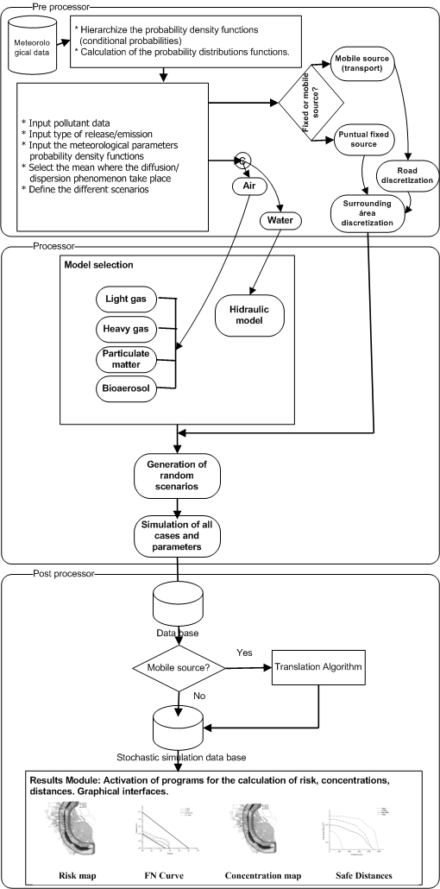

Figure 1: System calculus modules.

Once all the data (Figure 1) is entered to the system, the generation of random scenarios is carried out in the processor module, using the Monte Carlo methodology. Then, the model is selected according to items 2 and 3.
Finally, the simulation to obtain downwind concentration profiles is carried out. If a mobile source is analyzed (transport), a data compression algorithm (translation algorithm [6]) is applied in order to obtain the concentration histograms for all the affected receptors along the entire road. This procedure reduces considerably the calculation time without loss of accuracy ([4], [6]).
The post-processor includes this translation algorithm. It is also in charge of storing and managing the results for all the trials in the data base. Several subroutines or auxiliary programs have been developed to display all the results (risk maps, F-N curves, concentration maps, safe distances, etc) in a graphical way, making the user’s task easier.

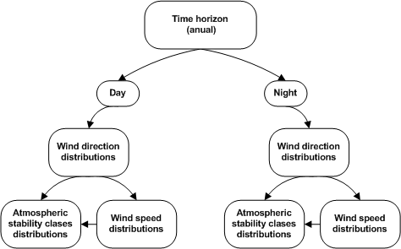

Figure 2: Hierarchical levels of probability density functions.

CONCLUSIONS AND FUTURE WORKS
The implementation of new modules to the STRRAP II computational system is described. This version is very useful in the diffusion/dispersion analysis of pollutant coming from fixed or mobile sources. In cases of transport accidents with dangerous material releases, the route is discretized in several segments. Simulation is carried out as if it were a fixed source and the output histograms are obtained applying the translation algorithm, which reduces the computational effort greatly.
Also, it is evident that risk analysis for railway or maritime transport can be solved in this way as well as for gas transport by pipelines.
As STRRAP considers the stochastic variability of the input model parameters, the system gives more realistic results than those obtained using the worst meteorological condition.
The system gives the possibility of including specific weather distributions of the region under study in the pre-processing phase. This is why this system is a valuable tool for technological and environmental risk assessment and emergency planning.
Finally, the optimization of the modular and hierarchical system architecture, the data storage strategies, the interconnectivity and flexibility of the different modules (pre-processor, processor, post-processor), and the input and output of data for the different calculus options will be done in future works.
As flowrates, rains and temperature series fluctuate along a time horizon for water dispersion, the handling of this time horizon will be studied.

ACKNOWLEDGEMENTS
The authors thank to Universidad Tecnológica Nacional, CONICET and Agencia Nacional de Promoción Científica y Tecnológica for their financial support to carry out this work.
REFERENCES
- D.F. Brown, A.J. Policastro et al, Development of the Table of Initial and Protective Action Distances for the 2000 Emergency Response Guidebook, October 2000.
- A.S.M. Santa Cruz, N.J. Scenna y M. Muñoz, “A Computational System for Risk Analysis of Incidental Toxic Gases Releases Considering Stochastic Variables,” en JAIIO 2002.
- W. Muñoz, Tesis para obtener el título de Magíster en Ingeniería en Calidad, titulada: Normas ISO 14000. Planes de Emergencia ante accidentes en el Transporte de Sustancias peligrosas. Cálculo de la zona de intervención considerando escenarios estocásticos cuando se producen fugas de sustancias Tóxico-Gaseosas, 2003.
- N.J. Scenna, A. S. M. Santa Cruz, S. M. Godoy y P.S. Biscotti, “STTRAP- A Software for Application in Risk Analysis and Emergency Planning,” en JAIIO 04 - AST Córdoba-Argentina, 2004.
- N.J. Scenna y A.S.M. Santa Cruz, “Road Risk Analysis due to the Transportation of Chlorine in Rosario city,” Reliability Engineering and System Safety, en prensa, 2004.
- S.M. Godoy, A.S. M. Santa Cruz y N.J. Scenna1, “A System For Risk Analysis Considering Atmospheric Parameters Uncertainty,” enviado a Empromer 05, Marzo 2005.
- R. Portielje, T. Hvited-Jacobsen^{M} y K. Schaarup-Jensen^{M}, “ Risk Analysis using Stochastic Reliability Method Applied to two Cases if Deterninistic Water Quality Models,” Water Research, vol.34, no.1, pp. 153-170, 2000.
- C.S. Cox, “The aerobiological pathway of microorganism,” New York: John Wiley & Sons, pp. 1-293, 1987.
- B.Lighthart, S. Frisch, “Estimation of viable airborne microbes downwind fron a point source,” Appl. Environ. Microbio, vol. 31, pp. 700-704, 1976.
- A. Bovallius, R. Roffey y E. Henningson, “Long Range Transmission of Bacteria,” Ann NY Acad Sci, vol. 353, pp. 186-225, 1980.
- T. Ciriani, W. Maione, “Mathematical Models For Surface Water Engineering,” Wiley, 1977.
- S. G. Wallis, “Simulation of Solute Transport in Open Channel Flow,” Mixing and Transport in the Environment, Chichester, John Willey ¬ Sons Ltd, pp. 89-111, 1994.
- J.F. Rodriguez, “Modelación unidensional y bidimensional del transporte de contaminantes en cursos de agua,” Ingeniería Hidraúlica en Méxic, vol. 12, no.1, pp. 5-14, 1997.

